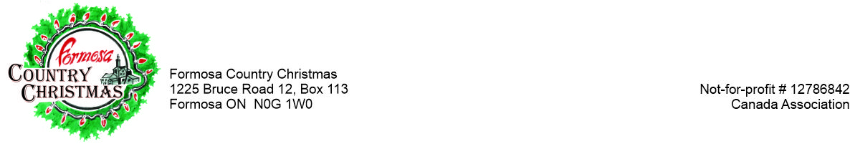October, 2022

***Hello, from the Formosa Country Christmas Committee!***

Each year we take the opportunity to contact our local community partners to see if they would like to be a part of this annual, festive event.

The Formosa Country Christmas is the largest drive-thru event in the region. It features literally thousands of lights, displays, exhibits and much more throughout the entire Hamlet of Formosa. Last year, over 7,000 people attended the event from over 83 different communities throughout Southern Ontario.

***This year, the event will be taking place on Thursday, December 1st to Sunday, December 4th, from 5 – 9pm.*** It will once again be a ‘drive-thru’ format, allowing everyone the opportunity to participate in this festive occasion.

Please note that this event is a ‘by donation only’ to ensure that everyone has an opportunity to enjoy this special light show.

***We sincerely hope you will take the opportunity to become involved.*** *Over the years****, our sponsors*** have made Formosa Country Christmas possible, allowing us to give back to the communities!

If you have any questions, please do not hesitate to contact us.

Most Sincerely,

The Fundraising Committee,

***Carl Zettel*** ***Shannon Wood***

519-367-5686 or [cmzettel@wightman.ca](mailto:cmzettel@wightman.ca) 519-901-9450 or [mildmaywoods@gmail.com](mailto:mildmaywoods@gmail.com)

***Bonny Fischer Marlene Bross-Durrer***

519-367-2732 [gernie61@hotmail.com](mailto:gernie61@hotmail.com) 519-367-2307 [marlene_bross@hotmail.com](mailto:marlene_bross@hotmail.com)

**SPONSORSHIP PACKAGES**

Promotional Options

|  |  |  |  |  |
| --- | --- | --- | --- | --- |
| **Promotional Options** | **Bronze**  ($499.00 and less) | **Silver**  ($500.00 - $999.00) | **Gold**  $1,000.00 - $4,999.00 | **Platinum**  $5,000.00 + |
|  |  |  |  |  |
| **Name and logo on the Event Flyer** |  |  |  |  |
| **Name and logo on the Event Flyer for a period of 5 years** |  |  |  |  |
| **Signage at the event** |  |  |  |  |
| **Special Plaque Prestation and Placement** |  |  |  |  |
| **Social Media Mentions** |  |  |  |  |
| **Social Media Mentions and a photo** |  |  |  |  |
| **Mentions on the website** |  |  |  |  |
| **Mentions on the website as well as your logo** |  |  |  |  |
| **The option of having your own sign / banner at the event** |  |  |  |  |
| **Mention and listing in the Event Press Release** |  |  |  |  |
| **Having your name and logo placed on the front page of the event website** |  |  |  |  |
| **The option of having your own lit system designed and signed by your company** |  |  |  |  |
| **Thank-you notification in the local papers** |  |  |  |  |
| **Free Event Passes** |  |  | (4) | (10) |